Infosci 401:Human Centered Systems, Fall 2020, Professor Perkoski

SportsU

Jonathan Azonca, jka27@pitt.edu

Ben Farbo bcf22@pitt.edu, Emily Galore emg114@pitt.edu, Emily Miller emm190@pitt.edu, Wenxin Wang [wew81@pitt.edu](mailto:wew81@pitt.edu)

1 December 2020

**Table of Contents**

Introduction/Problem Space………………………………………………………………….…2-3

Team Dynamics……………………………....……………………………………………........3-5

Product……………………………………………………………………………………..….......5

Lo-fi Prototype………………………………………………………………………………….5-8

High-fi Prototypes……………………………………………………………………………..9-12

Evaluation…………………………………………………………………………………….12-13

Attribution……………………………………………………………………………………13-14

Closing Section….…………………………………………………………………………....14-15

**Introduction/Problem Space**

The introduction of COVID-19 has affected many people’s lives, especially impacting the way people interact with each other. With this pandemic, many people are left with boredom, face difficult situations, and struggle to maintain what was the everyday norm. Due to the exposure, and risk of contracting COVID-19, many places of work have been forced to close down and/or reduce capacity, amount of employees, and open hours. This then caused many small businesses to shut down and resulted in many citizens becoming unemployed; leaving many people jobless and stuck inside their own homes.With people being stuck inside their households, physical exercise and activity has dropped significantly. Along with this the regulation of distancing oneself from other people has left many feeling much more lonely and isolated. Overall COVID-19 has brought about less movement, less collaboration, and less social interactions.Our group decided to solve this problem of inactivity with the creation of an outdoors activities app. This app is designed to provide a variety of features in hopes of being able to get people more active and to be more social all while maintaining COVID precautionary guidelines. The target audience for this app are those who want to maintain their health through physical exercise, adults, young adults, and children. But our main target audience is the youth and college campus students; with the target age group being between 16-26 (Specifically upper highschool and four year university students). We chose this age group specifically because our app relies on using verification through schools/universities, and we feel that the app would be most used by this age group, as they seem the most active. Though our app’s target audience age group is lower, people who are older still have the ability to join they just might not be able to get the full experience unless they are affiliated with a school/four year University.

Some limitations and constraints that we have included in our problem space is the use of public land, trying to maintain public health in a world of COVID, game rules, and lastly not enough users to be able to start a game. Public land is a hard constraint especially in a city where most of the public land is filled with buildings, such as the urban city of Pittsburgh. If there is not enough public land to play on, there is an extra option for the sports that are able to be played indoors. Indoor recreational facilities can be used to accommodate if there is little to no public land or if there are too many people in a certain area. For maintaining public health, the app would limit sports based on the current COVID risk level. For example, if the University of Pittsburgh is at an elevated risk would then cause the app to disable close contact sports such as football but leave sports like running, cycling, and swimming available to the user. For symptoms and the spread of the virus, those who sign up through a university such as University of Pittsburgh, the app requires the users to take the daily COVID test that Pitt has given before users are able to participate in activities. Those who wish to play with a mask on or without one, the app allows a user to search for sports whose participants are either wearing a mask or without. We hope for our users to use good judgement, be considerate, and maintain social distancing.

Before coming to our SportsU app design we examined two other problem spaces. The first problem space we examined was an app/interface device that would project a GPS onto the glass windshield of vehicles. This would work by connecting your phone through an app to the GPS device projecting to the windshield; displaying a variety of customizable widgets. We ended up deciding against this problem space though because we recognized that this could instead become more of a distraction to the users instead of actually being beneficial. The second problem space we explored was an app that helped the user cram for a test. The idea we came up with was that the application would help the users learn as fast as they could before an exam, working almost like a last minute study app. We ended up also deciding against this second problem space because when researching ways to study we found that cramming is one of the least effective ways to study. So as a group we came to the consensus that the best, and most relevant, problem space to tackle was the one that COVID-19 had brought about. We decided this because we feel that this problem space could also be legitimately beneficial to the public and serve to help benefit communities. To help facilitate open discussion, group work, sharing of opinions, and iteration within the project using each other's criticism our group decided to use a variety of technology to accomplish our problem space. Zoom was used to create meetings and decide on what was happening in the project. During the Zoom calls, we would get together and decide on what needed to be done and who was willing to take what task. The group leader didn’t decide on who got what part but was rather decided by the group members themselves. Whoever wanted to work on a certain part of the project could do so and opinions were openly encouraged to be shared consistently. In addition to the zoom calls, instead of trying to just rush and finish, we took time as a group and openly discussed each part of each assignment. Each of us communicated to one another, along with giving our opinions, on each assignment and each problem we encountered to better our answers; sometimes taking us multiple zoom calls to finish a problem. We all decided to meet in a Zoom call before the final decision was made on which idea to pursue and got everyone’s opinion. GroupMe, a text messaging app, was the app our group decided to use to keep everyone updated on anything that was happening related to the project. Not only did we use Zoom for meetings, we also used it to share our low fidelity prototypes and high fidelity prototypes with one another to critique and constructively criticize. Zoom has the ability to share a member’s screen and from there members, who were in charge of the prototypes, shared the prototypes with the rest of the team for feedback and discussion.

**Team Dynamics**

Our group leader is Jonathan Azcona and is given tasks maintaining group order, group focus, meeting deadlines, finalizing ideas, and starting documents and projects. For creating and setting up group meetings, we had used a variety of ways to get messages across all team members. We have used GroupMe and emails to create and schedule times to meet up and get focused. At each meeting, I would discuss what needs to be done, what we have, what responsibilities or tasks each member can do, and when our next meeting would be. Each scheduled meeting, I would ask each member what each of them have done since the previous meeting and a reminder of what deadlines are approaching. I had started some of the documents including the high-fidelity prototype and some of the documents that needed to be submitted.

Our group Powerpoint person was Ben Farbo and was given tasks of designing and helping in conceptualizing/building the hi-fi prototype: along with other features and tutorials for the app. Along with contributing to each assignment paper we received for our group. As stated above by Jonathan we used Zoom for our meetings to discuss and converse about our current tasks. Along with using Zoom as a place to share our ideas we also shared the prototypes to be able to improve and go back to change our designs as we went. We used the share screen feature for this. We as a group used Group Me, a messaging app, to be able to plan our Zoom meetings accordingly so every group member could make it to the meetings to contribute their ideas. Also using Group Me to communicate any questions, ideas, problems that may have popped up. For conflict resolution we agreed upon using group votes to settle anything that we struggled as a group to agree upon. Since there were five of us this strategy of solving problems worked out perfectly for our group. Though we as a group never had any huge disagreements and worked quite well together, making it a quite enjoyable experience all around everybody was awesome.

One of the Research people was Wenxin Wang and was given tasks of doing research for further discussion and designing the Hi-Fi prototype. As mentioned above, we used Groupme to communicate any challenges, suggestions, ideas in the whole project, and it is especially efficient in the prototype design phase. Due to Figma limits the number of editors, two members shared each draft in the Groupme and modified the prototype based on comments and suggestions contributed by all group members anytime. We also used Zoom to facilitate the Hi-Fi prototype design, discussing evaluation results and making last changes to the final draft in the Zoom meeting. And in the Zoom meeting, we used the screen share feature to see the changes of Hi-Fi prototypes synchronously, making sure that everyone was one the same page and decision-making was a group consensus.

Our group's writer/scribe was Emily Miller. I also created the lo-fi prototype. Beyond brainstorming, offering ideas, and critiquing the application from an idea to the hi-fi prototype, I gathered and summarized critiques from our in class presentation review and first and section iterations of the lo-fi prototype. I created the first iteration of the lo-fi prototype based off of reviews and recommendations of our classmates when our group leader presented our idea to the class. I then posted this to the Google Doc so my group mates could review and comment on it. With these critiques I made the second iteration of the lo-fi prototype and passed the criques from this round to the group members who designed the hi-fi prototype. I also kept track of our discussions through taking notes during our Zoom meetings and Group Me conversations in the Google Doc so everyone could remember what we discussed. I then summarized the process of designing the lo-fi prototypes for this final document and proof read the whole document.

One of the other Research people was Emily Galore and I was given the tasks of reviewing the documents, slides, and projects. I was key into highlighting important information throughout the duration of our project. As we worked through the different styles and designs, I began critiquing the lo-fi prototype, more specifically a lot of the authentication aspect of the application. I helped introduce the waiver and then explain why we should always use it for the application because it will help minimize legal difficulties if something happens while playing in the league our app is designed to make. I also helped create an idea of authentication so each member who joins the application, can find leagues for their specific school. This helps verify each individual.

**Product**

The most important feature of our app is the ability to create and join matches, which is the whole basis of our product. When matches are created there will be an official rule set as if they were playing in a professional setting. The user has the ability to see what other users are in the match and how many people are needed for the game. For example, if you tap on an event it will show you the details. When a game is created there will be a group chat for that game, giving users the ability to communicate with others. There will also be the option to mute chat notifications to avoid disruptions while in class, studying, etc.

Since Covid-19 is a large concern right now, we must be diligent in trying to keep everyone safe and healthy in our community. All participants will be required to complete a daily Covid-19 health check before joining the events. The health check will be a survey checking off on whether or not the participant has been in contact with someone who has tested positive for Covid-19, has any Covid-like symptoms, and has traveled out of the state in the last 14 days.

Contact sports will require a waiver to be signed prior to the game to avoid being held responsible for injuries. The waiver will make the participant aware that since Covid-19 can be transmitted through physical or shared contact with another person that by signing the waiver they agree to assume the risk. The waiver will also include the risk of injury while playing a contact sport and this is considered “part of the game” and by participating they accept the risk.

For security purposes, our app will require account authentication via student accounts through Universities. For example, when verifying through Pitt, the user will get a verified check showing they are affiliated with the school.

Lastly, our app will feature an interactive map that will show what sports are being played in real time. The user will be able to tap on event icons in the map and will be able to access/view the game that is currently available. If the user wants to see a certain game, the user can use the app’s filter to find a specific sport they would like to participate in.

**Lo-Fi Prototype**

* The first iteration of the application:

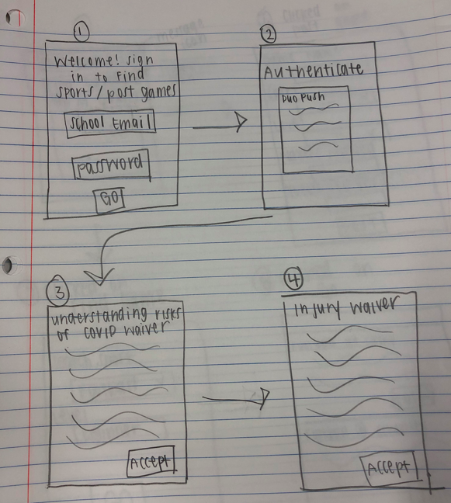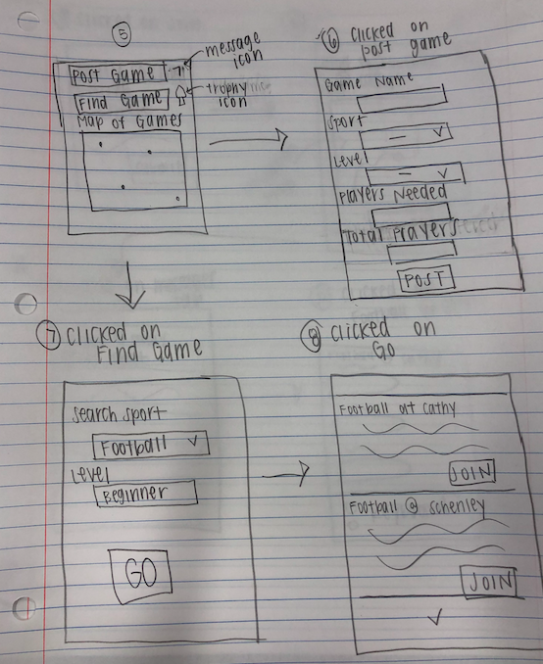

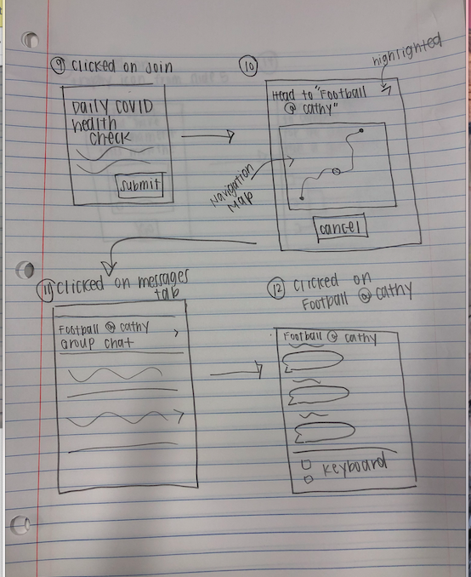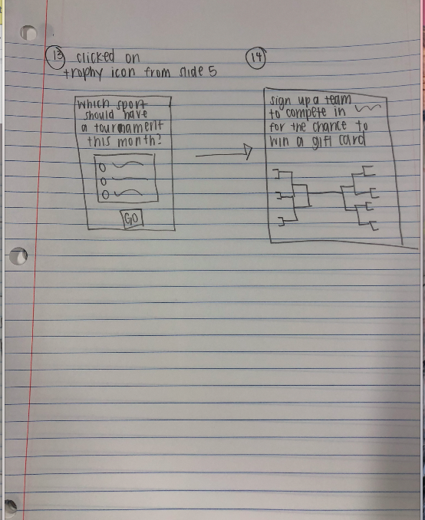

* To generate discussion about our lo-fi prototypes, we shared a picture of the paper prototype created by Emily Miller in our Google Doc so each group member could review, critique, and comment on it. Then, we met via Zoom and discussed the comments so that we could modify the changes in our hi-fi prototype. Below are the changes that we made to the first iteration of our lo-fi prototype that were generated by our discussion. These changes are exemplified in the hi-fi prototype and the second iteration of the lo-fi prototype.

1. When first logging in, instead of having a map that shows every game that is happening, as seen in slide 5 of the paper prototype, we decided to display the most popular sports in boxes and show their distance away from the user. This makes it easier for the user to see what sports are playing close by without overwhelming them or confusing them with ambiguous dots on a map that they have to click on to see what sports they are referring to.
   1. This also makes it easier for the user to either find a game to join or post a game without having to navigate through as many pages, which could lead to frustration. It’s more efficient to have the main goals of the app, finding and posting a game, on a page that appears right when you log in.
   2. While taking the map away from the home page, we made it so that the user can still see where the game is on a map once they click on the game that they might want to join. Incorporating the map here is useful because the user is interested in the game so knowing the location is important compared to seeing the location of every game going on like in the paper prototype.
2. We added to the date and an option to name the group message so the users have an easier time knowing which group message they are in. For example, in the paper prototype, the message name was just “Football @ Cathy”, but what if you played football at Cathy on multiple different dates? It would be hard to remember which group message was for each specific game.
3. We added a profile picture to pages that were unique to the user, like the homepage where they can decide to join an event, when they are about to join an event, and profile pictures to the group message. This not only makes the app more personalized, but is consistent with other social apps like instagram and Facebook where you can see your own profile picture and other’s profile pictures as well. This is especially useful in the chat feature: when you meet up to play a game with people you could be playing with complete strangers and not catch everyone’s name so when you chat after the game, it’s a nice way to put a name to a face by seeing each user’s profile picture by their message
4. More features we changed based on discussion and review of the low fidelity prototype were the ability to customize rules, the ability to see the rules and dates of the game you are interested in joining, a profile page, modifications to when a user has to complete the daily COVID health check, a navigation menu and more which are all discussed in further detail below in the Hi-Fi Prototype section. I didn’t include the detail here to reduce the redundancy of having the modifications in both places in this document.

* The second iteration of the Lo-Fi prototype, which the Hi-Fi prototype is based off of that was made considering the changes listed above: 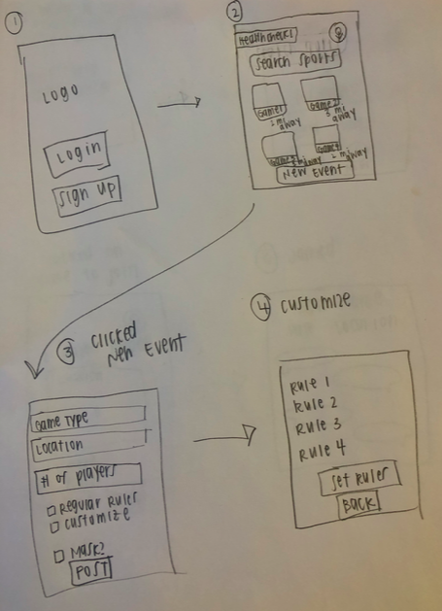

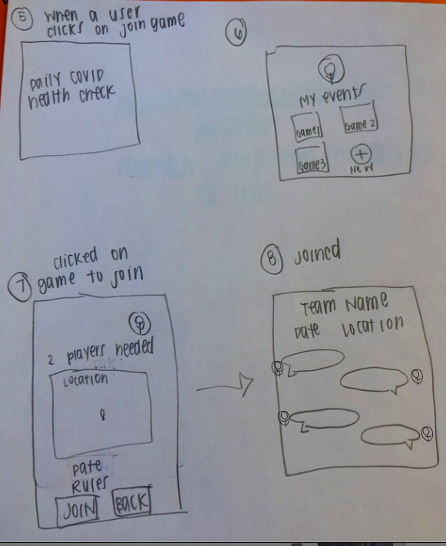

* Changes made to this prototype based on more discussion from our group mostly included overall aesthetic design and button details: for example the size, position, highlighting (and unhighlighting when an action isn’t doable like trying to join a game without completing the daily health check), and naming of the buttons. Some more changes were adding pages for logging in, with the option to log in using school credentials, and a Find your Password button for users that forgot their passwords. This feature is useful and common across almost every app that you see. Another change was a page for logging the Daily Covid Health check and viewing how many days you have completed it. Some of these changes are discussed in more detail below and can all be seen in the hi-fi prototype!

**Hi-Fi Prototype**

For our hi-fi prototype we decided as a group on the program Figma. We decided on this because we felt it gave us the proper tools to be able to accomplish what we wanted, and it allowed us to easily go back and edit as we revised/critiqued. Since Figma only allows two editors, the two members who worked on hi-fi prototype shared presentation links of each draft in Groupme, and all group members reviewed and commented on it. Then, we met and discussed the final draft over a zoom meeting to see if there’s anything else we needed to modify based on each group member’s usability test on the final draft. Below is a link to our first interactive hi-fi prototype and a small tutorial.

**Link to Prototype 1:** <https://www.figma.com/proto/65OFhFXi2zkbLtvjcsH9dS/Final-v1?node-id=1%3A22&scaling=scale-down>

Using your mouse you can navigate between different slides, right below the phone prototype, to be able to view every slide. Clicking anywhere on the prototype also allows you to go to the next slide. Lastly pressing the (r) key on your keyboard resets the prototype to the first slide.

**Slide 1:** This is our sign in slide and welcome page

**Slide 2:** This slide is an example of a user typing into the password box

**Slide 3:** This slide is what we planned on using for authentication, similar to how Pitt has students use the Duo Mobile

**Slide 4:** This slide is what we imagined the map aspect to be with the option to see games, find games, and post games

**Slide 5:** This slide is what the user would see if they had clicked on find game

**Slide 6:** This slide is what the user would see if they had clicked on post game

In our first prototype we mainly focused on trying to bring our lo-fi prototype to life so we could see what we could approve upon more. Keeping it simple so we could try different designs. From this our group discovered our original color scheme of a gradient blue-white background and grey buttons did not look as good as we first inticapted. So we began to test the first prototype with other colors such as blue and gold, blue and black, and lastly blue and white gradients backgrounds, while switching the buttons out for these new colors as well. As a group we collectively decided on a new design for the second prototype, which is made very apparent when first viewing it. We believe the new design and color layout provides a clean and modern design that our previous prototypes lacked.

For our second hi-fi prototype we worked in a team of two to accomplish our design, while having other group members critique and constructively criticize as we went; instead of just doing it all one go. Having our group members give feedback as we worked on the hi-fi prototype helped us build a much better design and layout. Along with adding a couple new quality of life features we didn't recognize at first until getting deeper into the design as a result of iteration and viewing other apps. Below is a link to the final draft of our prototype and a small explanation of each slide with what buttons work; along with where they go.

**Link to SportsU(Prototype 2):**

<https://www.figma.com/proto/g9wornwpos0YjkIHW4dxSO/SportsU?node-id=3%3A1&scaling=scale-down>

Once more using your mouse you can navigate between different slides, right below the phone prototype, to be able to view every slide. This time though clicking anywhere on the prototype won't allow you to go to the next slide; instead you will now have to navigate the app using the buttons we implemented. Lastly, as always, pressing the (r) key on your keyboard resets the prototype to the first slide.

**Slide 1:** This is our welcome page for SportsU, here you have two buttons. The “Log In” button will send the user to *Slide 3*, and the “Sign Up” button will take the user to *Slide 2*.

**Slide 2:** This is our signup page, here, users can sign up with their school email and student ID or simply by school credentials. On this slide clicking on the “Sign Up” button will take the user to *Slide 4*, clicking on “Log In” will take the user to *Slide 3.*

**Slide 3:** This is the login page. Users can login with their school email or simply by school credentials. Clicking on the “Log In” button will take the user to *Slide 4*, clicking on “Forgot Password” takes the user to *Slide 11*, and lastly clicking on “Sign Up” will take the user back to *Slide 2*.

**Slide 4:** This is the main page, or home page, for our app. Here, the user has many options; they can, click on the newly implemented button in the top left of the screen that will bring down a *Navigation Menu* for the users, click on any of the sports that have pictures on them which will take the users to *Slide 12,* click on “Start a New Event” which will take the users to *Slide 5,* and lastly they can click on the new “Health Check” notification in the top left which will take the users to *Slide 14*.

**Slide 5:** This is the create-event page. Users can choose to customize their rules and choose to require masks on or not on this page. In this prototype users can click on the “Customize” button taking them to *Slide 6,* or clicking on the “Post” button to go to *Slide 8.*

**Slide 6:** This is the customize-rule page where the users can change the preset rules or add a new one if they wish. Here when users click on the “Set Rules” button, or the “Back” button, it will send them back to *Slide 5.*

**Slide 7:** This is the school page for users to complete Daily COVID-19 Health Check and use Duo Mobile if needed by school. Clicking anywhere on the prototype will take the users to *Slide 13* after they have finished the health check.

**Slide 8:** This is the My Events page. It shows what events a user has joined and created. Clicking on any of the sports with pictures takes the user to *Slide 10,* and clicking on the “Create New Event” button takes the users back to *Slide 5.*

**Slide 9:** This is the Join-in page. Users can see all information and requirements of an event and choose to join in or not. As seen here we decided to move the map to see where games are being held, of the category that the user chose, to the join-in page for convenience. Clicking the “Join In” button sends the user to *Slide 10,* and clicking on the “Back” button takes the user to *Slide 4.*

**Slide 10:** This is the chat room. Our app will automatically create a chat room for each event, providing space for members to communicate. Clicking on the “Location” button allows for the user to see the location of the event in a quick way in the form of a drop down menu.

**Slide 11:** This is the Find-Your-Password page for improving the login process. Clicking on the “Find Your Password” button takes the user back to *Slide 3* automatically, and clicking on “Sign Up” takes the user to *Slide 2.*

**Slide 12:** This slide is what the user would see if they had not completed their daily health check before joining an event. Making it impossible for the user to join a game without taking the health check. Clicking on the “Unable to Join” button takes the user to *Slide 14,* and clicking on “Back” takes the user to *Slide 4.*

**Slide 13:** This slide shows a user’s health check records and how many days they have completed the health check. Clicking on the “Join Game” button , or the “Back” button, takes the user to *Slide 15.*

**Slide 14:** This slide is what the user would see had they not completed today’s health check. Here clicking on the “?”, or the “Health Check”, button will take the user to *Slide 7.* Clicking on the “Back” button takes the user to *Slide 4.*

**Slide 15:** This slide is what the user would see on the main page if they had completed today’s health check. Here, the user has many options once again; they can, click on the *Navigation Menu*, click on any of the sports that have pictures on them which will take the users to *Slide 12, or* click on “Start a New Event” which will take the users to *Slide 5,*

**Navigation Menu:** With this drop down menu users can navigate the app to different slides more efficiently. Originally we had designed the menu to come from the top of the screen, but as a group we decided to move it to come from the left to better fit the design. Here the user can; click on, the “Home” button to go to *Slide 15* (had they completed the health check), the “Start New Event” button to go to *Slide 5,* the “My Events” button to go to *Slide 8,* the “Health Check” button to go to *Slide 7,* and lastly the “Log Out” button to return to *Slide 1.*

Here are the changes we made to the final draft; based on, Lo-Fi Prototypes, Prototype 1, the usability test from in class(group presentation), and each group member's feedback from their usability tests as we developed the final draft:

* We added the capability to customize rules for a game that you post. This feature did not exist at all in the lo-fi prototype and prototype 1. It allows users to be able to personalize the games they want to play and for people looking to play games to know what to expect when they see a posting.
* Based on Prototype 1, we found out that users might join in multiple events and need to review each event at times. Therefore, we added the functionality to see the events you have posted and have a profile page. This makes the app more personable and makes it easier to remember and find what games you have posted and joined.
* We added the navigation function that helps users to find direction to events’ locations on each group chat page. Users can simply click the location button at the top of the chat room, and a built-in map will show the route from the user’s current location to event location. This function greatly improves user experience since users do not need to switch between apps to find directions.
* Based on the usability test in class(group presentation), health and safety during Covid is the biggest concern. To guarantee safety as well as improve user experience, we made it so the user cannot join or create a game unless they complete the health check instead of overwhelming the user with waivers like in the first lo-fi prototype. If a user doesn’t want to join a game and just wants to see events around them, it would be annoying to have to do the daily health check when first logging in again and again. This change ensures people who are planning to join a game complete the health check but doesn’t bother every single user with it when it isn’t necessary. It also allows the user to log their daily health checks so they can see how often they are doing it, and check to see if they completed it yet today.

**Evaluation**

The process that we have evaluated the product is that each team member would be given the high fidelity prototype and test it as if they were the user. To help study the evaluation of the product, we must study the product’s usability. Is it able to create a sporting event that a user wants to create? Is it able to search for the nearest sport that the user requested? Is the app easy to navigate? Is it helpful to reduce the health risks to our users during the pandemic COVID-19? These are some of the questions that are being tested during evaluation. These questions can be answered through usability testing.

Here’re several changes made as a result of conducting evaluation:

* One thing mentioned in the Hi-Fi prototype: to guarantee safety as well as improve user experience, we made it so the user cannot join or create a game unless they complete the health check instead of overwhelming the user with waivers. If a user doesn’t want to join a game and just wants to see events around them, it would be annoying to have to do the daily health check when first logging in again and again. This change ensures people who are planning to join a game complete the health check but doesn’t bother every single user with it when it isn’t necessary. It also allows the user to log their daily health checks so they can see how often they are doing it, and check to see if they completed it yet today.
* Based on usability testing, we found out that it is annoying for users to have to keep clicking the *back button* to go back to the main page(searching game and creating game). Therefore, we created a ***Navigation Menu***. With this drop down menu users can navigate the app to different pages more efficiently. ***Navigation Menu*** includes *Home* for users to go back to the main page, *Start New Event* for users can quickly create an event*, My Events* for users to find all their games*, Health Check* for users can directly see their health check records and complete today’s if not*,* and *Log out* for users to log out their accounts.
* Based on usability testing, we found out that it is necessary to add a function allowing users to switch between login and sign up, in case users mistakenly choose log in/sign up. Also, we added the Forgot *Password* function, in case users cannot log in due to forgetting their password.

**Attribution**

Jonathan: The final project document consists of all the team member’s contributions and not all parts of the document was done by only one person. Each team member was given a specific section of the paper but some sections of the final document was done by everyone on the team. Evaluation, attribution, high-fi prototype, team dynamics, and the introduction were the parts that all team members had contributed. In terms of contribution to the project and to the team, I believe that I have contributed my part in the project. Finalizing what times we meet and when we meet is one of the tasks that I have done. I have also started some of the projects and get everyone prepared for each of their tasks. For example, I tried to figure out Figma, our high fidelity prototype software, and help as much as possible so that the team members can get a gist of how to use that software. I have helped create some of the documents that we have used for the project such as this one and bring together what everyone has to say. In terms of contribution to the final project document, I have done the introduction, team dynamics, basic layout, attribution, and part of the high-fi prototype.

Ben: Overall working together as a team on this project was a good experience, and felt like everybody was able to pull their own weight, while still working together to finish the tasks that were at hand. For my contribution to the team I always took a task on for each assignment we were given, such as the introduction on HW3 Basic Outline. Along with always trying to give my opinion in a respectful way to help further our groups discussion in design and iteration. I also worked with Jonathan on the first hi-fi prototype, and the figuring out the art design/layout for our final draft. After that I helped in designing the creation of the final draft hi-fi prototype with Wenxin on Figma, working together to add features we found as we created and received feedback. For the final project paper I worked with Jonathan to write the Introduction and then proofread after. Similarly, I worked with Wenxin as well, on the Hi-fi prototype part of the paper; writing this part of the paper and proofreading after.

Wenxin: The whole team contributed to this project. Each member received a specific role in this project, and everyone did a great job of focusing on their tasks. In terms of attribution to this project and the team, I have always given my thoughts and opinions on further works and discussions, contributed my ideas when brainstorming ideas of this project, researched the evaluation process, and found suitable Hi-Fi prototype design software. For the final project, I was responsible for designing Hi-Fi Prototype 2 based on Lo-Fi Prototype and Prototype 1 with Ben's help. Before I started, I summarized the critiques and changes that our team members made for the lo-fi prototypes during the meeting and then applied to the Hi-Fi prototypes. During the design process, I continuously modified and added features to our Hi-Fi Prototype based on members' suggestions and evaluation results to improve our app's usability. Eventually, I was in charge of writing the "Evaluation" section and worked with Ben on the “Hi-Fi prototype” part for this report by organizing and recording changes for these sections. Meanwhile, I assisted in the final readthrough with other group members to see if we miss some critical information. Overall, our group did a great job of collaborating as we helped each other a lot and splitting the work.

Emily Miller: While everyone in the group contributed to the Lo-Fi prototype by critiquing it and offering feedback for both iterations, I summarized this information in the Lo-Fi section of this document. I uploaded pictures of both of the iterations that I drew and pointed out the changes that were made during each iteration. I worked with Wenxin to make sure that the changes described in the Hi-Fi and Lo-Fi sections were not repeated in detail twice to reduce redundancy in the paper. I made sure that critiques that were emphasized or repeated by more than one person, like the safety and taking measures to prevent COVID that many classmates were worried about during our idea presentation to the class, were acknowledged by changes in the designs, like adding the Daily Covid Health Check feature. Beyond creating and summarizing critiques to create changes to the two iterations of the Lo-Fi prototype and Hi-Fi prototype, during our Zoom meetings and Group Me conversations, I contributed to and took notes on conversations and general ideas for the project in our shared Google Doc.

Emily Galore: The overall success of this project was contributed by every team member, which I felt we did a great job using everyone’s different skill sets to complete each task. For my contribution to the team I helped brainstorm ideas during group discussions and listened to others when they had a lot of really good ideas. I reviewed the different documents that were attached and then helped the group distinguish different areas we should focus on. I also helped organize the slides of importance as well as helped critique different ideas of the prototypes. I focused a lot on the waivers being important due to the future legal complications we could go through as well as the authentication and organization of the app. This will help verify students and keep track of the schools that they attend which can help them find games faster as well as create leagues that can reach all members of the app.

**Closing**

Jonathan: This project had opened my eyes to creating a product. Not only is a good purpose the sole reason a product is successful, it is also the process of creating the good product. The product should go through many iterations before the finalized product is released into the wild. It requires testing, evaluation, studies, opinions, and many other attributes to become a final product. I, Jonathan, have learned that this process takes a long time and that each part of the process is important. One cannot forget an audience, one should make assumptions about anything. Opening a product up and telling what it should be able to do to others is key. The criticism from others helps the product become better than before.

Ben: This project was an enlightening experience about the surprising depth that goes into actually creating a product. I learned a lot about the process through the iterations our group conducted in creating our prototypes, especially the design phase, and figuring out what actually worked compared to what we thought would work. The other surprising thing about this project was how much I enjoyed doing it with our zoom groups compared to meeting in real life. Conducting meetings online with each other made it feel lower pressure with our group having the ability to meet anytime consistently due to being online. Along with this, due to our group collaborating online, we were all able to contribute in our own meaningful ways whenever we wanted with being able to access the documents and material at any time. Overall a good and insightful project to learn about the HCI business, and its practices.

Wenxin : This project provided me a great opportunity to learn and design softwares. I was interested in human centered design, but this is the first time I can actually practice and apply what I learned to real design. Although our Hi-Fi prototype may not be the best, I’m really proud of our final product because I put efforts and time into constructing it, improving it, and solving problems by continuously testing and watching tutorials. It is incredible to become an app developer from a user. All of the challenges and surprises perfected my experience in this project and this class. This project is also a wonderful team work experience for me. I really appreciate that there are four wonderful teammates sharing ideas and collaborating on this challenging project with me during this special time. I think it is really interesting and helpful to have this group project for this course.

Emily Miller: This project gave me much needed experience creating lo-fi prototypes and working through the design process with a group. Sometimes it’s hard to put ideas in your head on paper, and this project made me work through this. The critiques I received on the lo-fi prototype pointed out areas where I made things more complicated than they needed to be or didn’t put enough thought into. Although meeting via Zoom could be a challenge to some, I thought that it made it easier to find a time for us to meet and to each work on the project at the same time while discussing questions if we had any. My only suggestion would be to maybe have more checkpoints with the professor throughout the process to make sure we are on the right track for what’s expected out of the final design. I know we did have some check ins but maybe more structured check ins would be helpful in the future since a lot of this information is new and students haven’t applied it before! Overall, I think projects like this are really important for us to get “real world” experience applying what we learned in class. While working through the project, I would think of so many different things that we learned throughout the semester that our group applied.

Emily Galore: This project gave me an opportunity to really dive in depth in constructing a mobile application. I felt very interested in some aspects of the project overall. I really enjoyed learning about how we could make our app the best it can be. I thought listening and critiquing other ideas was important to gain massive success. I thought the zoom meetings were rough, due to the work I have accumulated in my other class, but I managed to attend and give my best effort. This is a fantastic team building project that can activate a lot of creative minds. This being said, it really helped me learn from myself as well as from my teammates. A suggestion I had was to maybe create more check ins. I felt as if we didn’t have enough at times and became kind of confusing but with the help of my teammates, we managed to pull through. Overall, it was a great project and I highly recommend it for future students as it really encompassed the main priorities and skills we have learned throughout the semester.